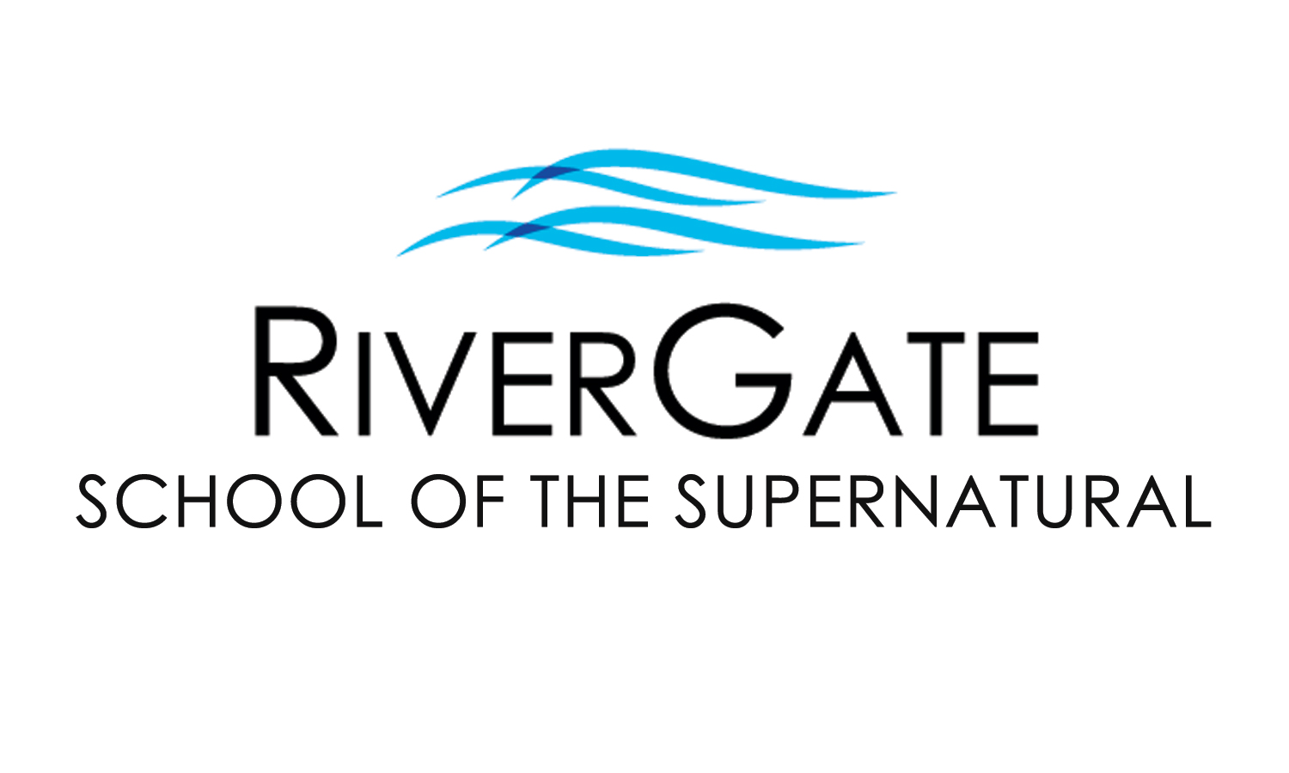

**2024 FALL CLASS OFFERINGS**

The RiverGate School of the Supernatural seeks to raise up a new generation of humble, lovesick worshippers who have a prophetic edge with the character to match the anointing in their lives. We desire that you experience the Father’s love and learn how to give it away. RGSS consists of three levels of excellence and training. For more info, please contact us at 918-492-5511x39 or [*RGSS@rivergatetulsa.org*](mailto:RGSS@rivergatetulsa.org)*.*

**ONLINE LEARNING OPTIONS:** We welcome students to join us from anywhere! Online-only enrollment does incur an additional cost to cover the shipment of materials that are included in the class. This cost varies by class and is indicated below.

**OUR MOST POPULAR SUNDAY NIGHT CLASSES:**

**HEALING OF THE HEART PART 1 (FL301-1) & PART 2 (FL301-2)** *(Pastor Cristin will teach Breaking Free 1 live this semester.)*

Have you been a Christian for some time, or even a new Christian, and wounds and hurts from your past still haunt you? Perhaps difficult circumstances & relationships just seem to be a normal part of life? This two-part class has been developed to help you be set free from your past. Topics include the importance of forgiveness, father/mother issues, overcoming rejection & abandonment, healing from abuse, performance orientation, inner vows & bitter root judgments, and more! *These classes were written by Pastor Cristin Hamman.*

**PART 1 (FL301-1)**

**Prerequisites:** None / **Early** **Registration:** $81 by Aug 25th, 2024 / **Registration:** $109 after Aug 25th, 2024 / **Online Only:** +$20

**Class Dates:** Sundays @ 6pm for 9 weeks, beginning September 8th, 2024 (No classes on September 15th & October 20th.)

**PART 2 (FL301-2)**

**Prereqs:** Healing of the Heart 1 (FL301-1) / **Early** **Registration:** $81 by Aug 25th / **Registration:** $109 after Aug 25th / **Online Only:** +$20 **Class Dates:** Sundays @ 6pm for 9 weeks beginning September 8th, 2024 (No classes on September 15th or October 20th

**OUR MOST POPULAR WEDNESDAY NIGHT CLASSES:**

**BREAKING FREE PART 1 (FL302-1) & PART 2 (FL302-2)** *(BF1 will be taught live by Pastor Cristin & BF2 by Pastor Joel this semester.)*

Do you find yourself struggling with the same issues, health problems, and personal conflicts? Chances are likely you have “open doors” that have allowed the demonic to have access & trespass in your life, possibly harassing you & your family for years, even generations. In Part 1, you’ll identify “open doors” in your life and learn how to experience freedom from torment. You’ll receive personal ministry & hands-on training for a life of freedom. Part 2 goes deeper, helping you identify familiar & religious spirits as you investigate how the enemy would like us to become unwitting instruments through the four faces of Jezebel. By conclusion, students learn how to build a shield of honor & prepare for a visitation from the Lord. *These classes were written by Pastor Cristin Hamman.*

**PART 1 (FL302-1): Prerequisites:** None / **Early Registration:** $99 by Aug 28th / **Registration:** $129 after Aug 28th / **Online Only:** +$20

**Class Dates:** Wednesdays @ 6:30pm for 8 weeks, beginning Sept 11th, 2024 (No class on October 16th for Fall Break.)

**PART 2 (FL302-2): Prereq:** Breaking Free 1 (FL302-1) / **Early** **Registration:** $117 by Aug 21st / **Registration:** $142 after Aug 21st **/ Online Only:** +$30 / **Class Dates:** Wednesdays @ 6:30pm for 10wks beginning September 4th, 2024 (No class on October 16th for Fall Break.)

**BREAKING FREE WEEKEND is Sat, Nov 2nd, 2024 (8:30am – 4pm)** and is required for Part 1 students (optional for Part 2 students). The cost for this event is included in enrollment. Alumni of Breaking Free 1 may participate for $25 w/ advanced registration or $30 at the door.

**DREAM LANGUAGE (PI203)**

God desires to communicate with us through dreams and nighttime visions, but it is only as we gain understanding of how to unlock these hidden messages that we will be able to take full advantage of what He’s saying. In this class, you’ll learn to listen to the language of your dreams, gain strategies for having an active dream life, understand the basic steps for interpreting dreams, practice interpreting and delivering interpretations for others, and gain knowledge concerning how to act on what you dream. W*ritten by Pastor Cristin Hamman.*

**Prerequisites:** Effective Prophetic (PI202)

**Early Registration:** $81 by August 21st, 2024 / **Registration:** $109 after August 21st, 2024 / **Online Only:** +$30

**Class Dates:** Wednesdays at 6:30pm for 10 weeks beginning September 4th, 2024 (No class on October 16th for Fall Break.)

**MORE CLASSES FEATURED ON THE REVERSE SIDE**

*Please fill out the information below & on the reverse side. You may detach & turn it in with the offering or at the front desk before/after service.*

Name: Today’s Date: / /

Address: City: Zip:

Cell Phone: Email:

Concerning Children’s Ministry, I will need (indicate # in blank): ____ None _____ Nursery/Preschool _____ Elementary _____ Youth

Check one: I am enrolling with payment today (please complete reverse side).

I would like to be contacted before enrolling or to enroll over the phone. Please call me.

**MORE WEDNESDAY CLASSES THIS SEMESTER:**

**HEARING THE VOICE OF GOD (FL305)** [This class is only available in-person.]

This class will teach you how to discern God’s voice from all other voices that clamor for your attention. You’ll receive vital keys to increase the intimacy of your prayer time, to be still before the Lord, as well as recognize His speech. You’ll experience a depth of relationship with God you never thought possible!

**Prerequisites:** None / **Early Registration:** $49 before August 28th, 2024 / **Registration:** $59 after August 28th, 2024

**Class Dates:** Wednesdays @ 6:30pm for 8 weeks beginning September 11th, 2024 (No class on October 16th for Fall Break)

**EFFECTIVE COMMUNICATION (FL202)** *(This class will be taught by Pastor Cristin Hamman.)* [This class is only available in-person.]

Communication breakdowns and misunderstandings are the primary causes for division in all relationships, including marriage, employee/employer, friendships, parenting, and more. In this hands-on class, students will learn and practice healthy approaches to communicating completely, fighting fair, and resolving conflicts. Applying the principles of this class leads to more teamwork in personal, familial, and professional relationships, helps to eliminate misinterpretation of messages, and defends relationships from dishonor and disaster. Enrollment in this class is done in pairs and includes two sets of materials, as you’ll need someone to practice and have fun with.

**Prerequisites:** None / **Early Registration:** $45/one person or $74/two people by Aug 14th, 2024 / **Registration:** $55/one person or $99/two after August 14th / **Class Dates:** Wednesdays @ 6:30pm for 3 weeks – August 28th, September 4th, and September 11th, 2024

**MORE SUNDAY CLASSES THIS SEMESTER:**

**HEALING CLINIC (HD 201)** *(This class will be taught by Pastor Linda Budd.)* [This class is only available in-person.]

This class focuses on the biblical basis of healing and gives students how-to practical teaching for healing the sick and walking in a healing anointing and provides guided, hands-on practice opportunities in each session. As the class meets, “the clinic” is open to any who have pain/sickness in their body and desire to receive healing. Enrolled students receive teaching with a provided manual and are mentored as they practice receiving and delivering words of knowledge for those attending the clinic, often seeing clinic attendees receive immediate healing. Students are given strategies to invite people to attend “the clinic” and are encouraged to bring someone with them weekly.

**Prerequisites:** None / **Early Registration:** $64 by August 25th, 2024 / **Registration:** $89 after August 25th, 2024

**Class Dates:** Sundays @ 6pm for 8 weeks beginning September 8th, 2024 (No classes on September 15th or October 20th.)

**SPIRITUAL DISCERNMENT PART 3: BIBLICAL BASIS FOR SPIRITUAL CONFLICT (HD103)** [This class is only available in-person.]

This class builds on what was discovered in Parts 1 & 2, yet it can also stand alone in the four-part series. In this class you will learn about spiritual warfare, what the Bible has to say about it, your role in it, the weapons you have been given, and how to use them effectively. This class addresses many questions believers have about God regarding spiritual warfare, why it’s necessary, and what He commissions us to do. This class provides crucial information for anyone who desires to be effective in spiritual warfare instead of becoming a casualty of it. *(This will be facilitated by Pastor Joel Budd.)*

**Prerequisites:** None / **Early Registration:** $74 before Aug 25th, 2024 / **Registration:** $99 after Aug 25th, 2024

**Class Dates:** Sundays @ 6pm for 8 weeks beginning September 8th, 2024 (No classes on September 15th or October 20th)

**FOUNDATIONS (CHRISTIANITY 101)** [This class is only available in-person.]

In today’s world of complicated messages, it’s refreshing to have a simple but profound message of God’s love and grace. It’s comforting to know His purpose for us as believers. Whether one is new to following Jesus or has been for quite some time, sometimes it’s good to stop and consider some of the foundational truths of our faith. In this class, students will establish (or reestablish) the solid foundation of their faith, as well as develop invaluable tools to know God and walk in partnership with Him. Together we will discover Jesus in a new way and learn how to help others discover Him too! *This class was written by Glenn Shaffer.*

**Prerequisite:** None / **Early Registration:** $29 by August 25th, 2024 / **Registration:** $39 after August 25th, 2024

**Class Dates:** Sundays at 9am for 11 weeks beginning September 8th, 2024. (Water Baptism class on November 3rd is optional.)

**WATER BAPTISM (FL102)** [This class is only available in-person.]

This class gives the Bible’s definitive teaching on the significance of water baptism, including why people are baptized when they become believers, its purpose, who should be baptized, and how a baptism should be conducted. Those who complete the class are invited to participate in the water baptism that same day during the main service. Participants should bring a towel and a change of clothes. (Students under 12yrs must receive pastoral approval prior to baptism.) *This class was written and developed by Pastor Cristin Hamman.*

**Prerequisites:** None / **Cost:** Free / **Class Date:** Sun morning, November 3rd, 2024 @ 9am (baptism during the 10:30am service)

**Child/Dependent Care:** Children’s/Youth Ministry are offered during regular service times, in conjunction with our classes. For any classes/events outside of regular RGC service times, child/dependent care is not provided and must be arranged by the RGSS student, as only nursing babies are permitted in class.

**We love you as you are and want to give away what we have learned over our years of ministry and we want you to be lessed mightily as God takes you to where He knows you can be. Come join us in the School of the Supernatural this semester. This journey together will be a wonderful adventure in the Father’s love & power!**

*Please fill out the information below & on the reverse side. You may detach & turn it in with the offering or at the front desk before/after service.*

**Class(es) I am interested in and/or would like to enroll in:**

Class 1: In person: Online: Price:

Class 2: In person: Online: Price:

**If enrolling by credit card, both sides must be filled out completely. Total:**

Debit/Credit Card #: - - - Exp. Date: /

Print name: Signature:

**Office Use Only:**

Cash

Check #:

Credit

Processed date: