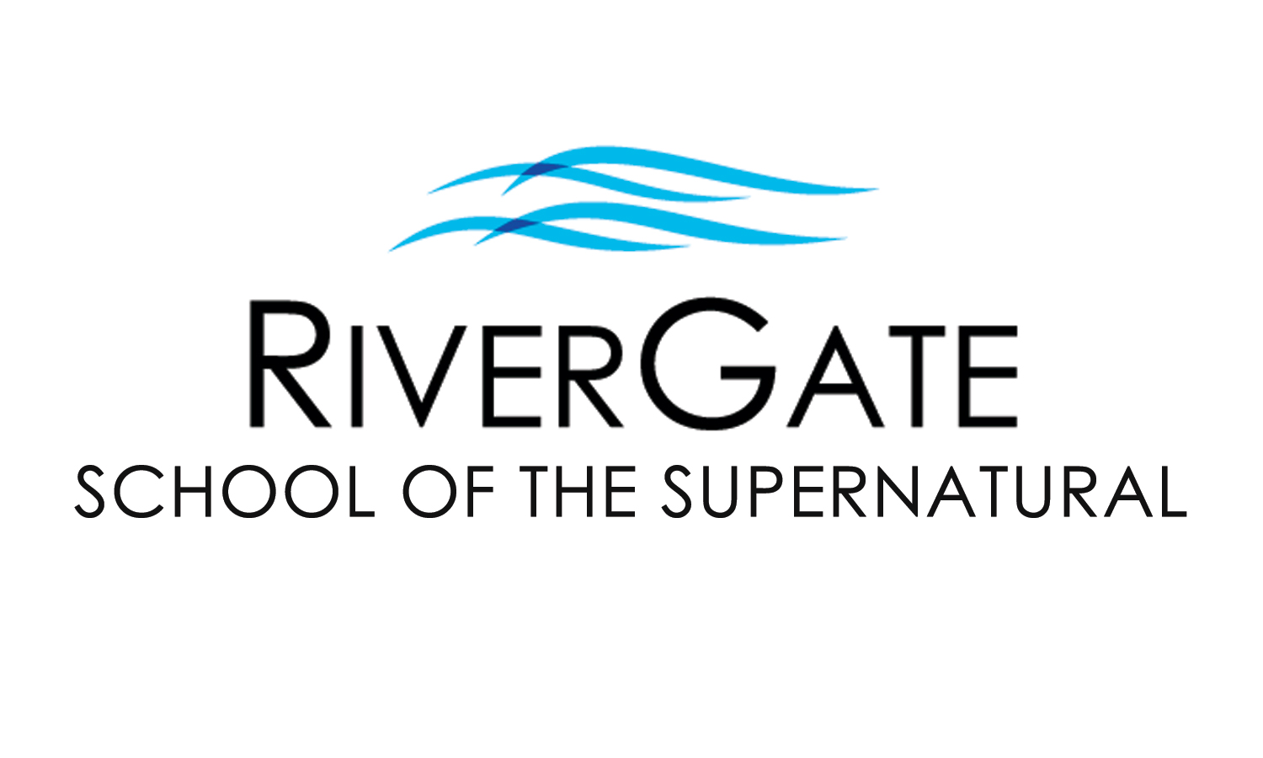

2024 SPRING IN-PERSON CLASS OFFERINGS

The RiverGate School of the Supernatural seeks to raise up a new generation of humble, lovesick worshippers who have a prophetic edge with the character to match the anointing in their lives. We desire that you experience the Father’s love and learn how to give it away. RGSS consists of three levels of excellence and training. For more info, please contact us at 918-492-5511x39 or RGSS@rivergatetulsa.org.

ONLINE LEARNING OPTIONS NOW AVAILABLE!: Remote learning options are now available for most of our classes and feature special pricing options too. Please contact our office for more info. We are now able to welcome students from everywhere!

OUR MOST POPULAR WEDNESDAY NIGHT CLASSES:

HEALING OF THE HEART PART 1 (FL301-1) & PART 2 (FL301-2)
Have you been a Christian for some time, or even a new Christian, and wounds and hurts from your past still haunt you? Perhaps difficult circumstances & relationships just seem to be a normal part of life? This two-part class has been developed to help you be set free from your past. Topics include the importance of forgiveness, father/mother issues, overcoming rejection & abandonment, healing from abuse, performance orientation, inner vows & bitter root judgments, and more! These classes were written by Pastor Cristin Hamman.
PART 1 (FL301-1)
Prerequisites: None / Early Registration: $76 by January 17th, 2024 / Registration: $104 after January 17th, 2024
Class Dates: Wednesdays @ 6:30pm for 10 wks, beginning January 31st, 2024 (No classes on March 20th for Spring Break.)
PART 2 (FL301-2)
Prerequisites: Healing of the Heart Part 1 (FL301-1) / Early Registration: $76 by January 17th / Registration: $104 after January 17th
Class Dates: Wednesdays @ 6:30pm for 9 wks beginning January 31st, 2024 (No class on March 20th for Spring Break.)

OUR MOST POPULAR SUNDAY NIGHT CLASSES:

BREAKING FREE PART 1 (FL302-1) & PART 2 (FL302-2) (Breaking Free Part 2 will be taught live by Pastor Joel this semester.)
Do you find yourself struggling with the same issues, health problems, and personal conflicts? Chances are likely you have “open doors” that have allowed the demonic to have access & trespass in your life, possibly harassing you & your family for years, even generations. In Part 1, you’ll identify “open doors” in your life and learn how to experience freedom from torment. You’ll receive personal ministry & hands-on training for a life of freedom. Part 2 goes deeper, helping you identify familiar & religious spirits as you investigate how the enemy would like us to become unwitting instruments through the four faces of Jezebel. By conclusion, students learn how to build a shield of honor & prepare for a visitation from the Lord. These classes were written by Pastor Cristin Hamman.
PART 1 (FL302-1): Prerequisites: None / Early Registration: $96 by January 28th, 2024 / Registration: $121 after January 28th, 2024
Class Dates: Sundays @ 6pm for 8 wks, beginning February 11th, 2024 (No classes on Feb 4th, Feb 18th, March 17th, or March 31st) PART 2 (FL302-2): Prerequisites: Breaking Free 1 (FL302-1) / Early Registration: $117 by Jan 14th / Registration: $142 after Jan 14th
Class Dates: Sundays @ 6pm for 10wks beginning January 28th, 2024 (No classes on Feb 4th, Feb 18th, March 17th, or March 31st)
BREAKING FREE WEEKEND is Sat, April 20th, 2024 (8:30am – 4pm) and is required of Part 1 students (optional for Part 2 students). Cost for this event is included in enrollment. Alumni of Breaking Free 1 may participate for $25 w/ advanced registration or $30 at the door.

EFFECTIVE PROPHETIC / DREAM LANGUAGE PART 1 (PI202)
This class teaches you how to operate in the prophetic with relevance. You will acquire and practice the prophetic gift as you learn guidelines for the discipline and maturation of this gift and strategies for communicating God’s heart in a way that can easily be understood by anyone. This class also lays the foundation for learning how to interpret dreams. Written by Pastor Cristin Hamman.
Prerequisites: Healing of the Heart Part 1 (FL301-1) & Breaking Free Part 1 (FL302-1)
Early Registration: $76 by January 28th, 2024 / Registration: $104 after January 28th, 2024
Class Dates: Sundays at 6pm for 9 wks beginning February 11th, 2024 (No classes on Feb 4th, Feb 18th, March 17th, or March 31st)
PLEASE NOTE: This is a prerequisite for Dream Language, which will be offered next semester. Each class is only offered once a year.
MORE CLASSES FEATURED ON THE REVERSE SIDE

Please fill out the information below & on the reverse side. You may detach & turn it in with the offering or at the front desk before/after service.

Name: Today’s Date: / /

Address: City: Zip:

Cell Phone: Email:

Concerning Children’s Ministry, I will need (indicate # in blank): ____ None _____ Nursery/Preschool _____ Elementary _____ Youth

Check one: I am enrolling with payment today (please complete reverse side).
I would like to be contacted before enrolling or to enroll over the phone. Please call me.

MORE WEDNESDAY NIGHT CLASSES THIS SEMESTER:

EVERYDAY APOLOGETICS: REAL FAITH, FALSE RELIGIONS, & REAL CONVERSATIONS (EV101)
The more we engage with others, the more we encounter diverse worldviews. How can we be salt and light to people who believe differently if we don’t know what they believe or how to talk to them? This class will help you understand the basics of several worldviews, including atheism, agnosticism, New Age, Islam, Buddhism, Mormonism, Catholicism, Judaism, Scientology, Wicca, LGBTQ+, and more. As you interact with the teacher, other students, and the Bible, you’ll learn how to be a disciple of Jesus who stands firm in what you believe while lovingly challenging others in meaningful, non-religious conversations. Written and taught live by Pastor Cristin Hamman.
Prerequisites: None / Early Registration: $69 before January 17th, 2024 / Registration: $94 after January 17th, 2024
Class Dates: Wednesdays @ 6:30pm for 9 wks beginning January 31st, 2024 (No classes on March 6th or March 20th, 2024)

SPIRITUAL DISCERNMENT 2: SPIRITUAL SERVANTS OF THE MOST HIGH GOD (HD101) (This will be facilitated by Pastor Joel Budd.)
This class builds on what was discovered in Part, yet it can also stand alone if you wish to dive into our four-part series. Many of us grew up with a simple view of the spiritual world consisting of God-vs-Satan and angels-vs-demons, but as we grow in intimacy with the Father, our spiritual worldview is stretched. In this class, students learn the biblical foundation for discerning spiritual beings, including types and reasons for their presence, and receive hands-on practice to interact with Heaven. Hebrews 5:14: “But solid food belongs to those who are of full age, that is, those who by reason of use have their senses exercised to discern both good and evil” (NKJV).
Prerequisites: None / Early Registration: $69 before January 17th, 2024 / Registration: $94 after January 17th, 2024
Class Dates: Wednesdays @ 6:30pm for 8 wks beginning January 31st, 2024 (No classes on March 6th or March 20th, 2024)

MORE SUNDAY CLASSES THIS SEMESTER:

FRESH WORD: ARTICULATING YOUR STORY & HIS STORY (EV201)
You have a story, and it’s worth telling. In fact, your story is the second greatest story ever told. In this class, students will learn to articulate both their testimony and the Word of God in real and relevant ways as they receive instruction and mentoring from Pastor Cristin Hamman. With hands-on practice and small group exercises, students will prepare, practice, and present powerful personal testimonies, mini-sermons, and meaningful messages that define God’s redemptive work in the world. Learn how to draw people closer to the Father’s heart as an authentic disciple of Jesus who can teach and preach. It’s fun and easier than you think! Note: Class size is limited to 8 student applicants. Some may be put on a waitlist.
Prerequisites: Healing of the Heart Part 1 (FL301-1) & Breaking Free Part 1 (FL302-1)
Early Registration: $69 by January 28th, 2024 / Registration: $94 after January 28th, 2024
Class Dates: Sundays @ 6pm for 8 wks, beginning February 11th, 2024 (No classes on Feb 4th, Feb 18th, March 17th, or March 31st)

FOUNDATIONS (CHRISTIANITY 101)
In today’s world of complicated messages, it’s refreshing to have a simple but profound message of God’s love and grace. It’s comforting to know His purpose for us as believers. Whether one is new to following Jesus or has been for quite some time, sometimes it’s good to stop and consider some of the foundational truths of our faith. In this class, students will establish (or reestablish) the solid foundation of their faith, as well as develop invaluable tools to know God and walk in partnership with Him. Together we will discover Jesus in a new way and learn how to help others discover Him too! This class was written by Glen Shaffer.
Prerequisite: None / Early Registration: $29 by January 21st, 2024 / Registration: $39 after January 21st, 2024
Class Dates: Sundays at 9am for 11 weeks beginning February 4th, 2024 (No classes on March 17th, 2024 and March 31st, 2024). Included in this class, participants will attend the Water Baptism class on April 21st and have the opportunity to participate if they wish.

WATER BAPTISM (FL102)
This class gives the Bible’s definitive teaching on the significance of water baptism, including why people are baptized when they become believers, its purpose, who should be baptized, and how a baptism should be conducted. Those who complete the class are invited to participate in the water baptism that same day during the main service. Participants should bring a towel and change of clothes. (Students under 12yrs must receive pastoral approval prior to baptism.) This class was written and developed by Pastor Cristin Hamman.
Prerequisites: None / Cost: Free / Class Date: Sun morning, April 21st, 2024 @ 9am (baptism during the 10:30am service)

Child/Dependent Care: Children’s/Youth Ministry are offered during regular service times, in conjunction with our classes. For any classes/events outside of regular RGC service times, child/dependent care is not provided and must be arranged by the RGSS student, as only nursing babies are permitted in class.

Please fill out the information below & on the reverse side. You may detach & turn it in with the offering or at the front desk before/after service.

Class(es) I am interested in and/or would like to enroll in:

Class 1: In person: Online: Price:

Class 2: In person: Online: Price:

If enrolling by credit card, both sides must be filled out completely. Total:

Debit/Credit Card #: - - - Exp. Date: /

Print name: Signature:

We love you as you are and want to give away what we have learned over our years of ministry and we want you to be lessed mightily as God takes you to where He knows you can be. Come join us in the School of the Supernatural this semester. This journey together will be a wonderful adventure in the Father’s love & power!
Office Use Only:
Cash
Check #:
Credit

Processed date:

