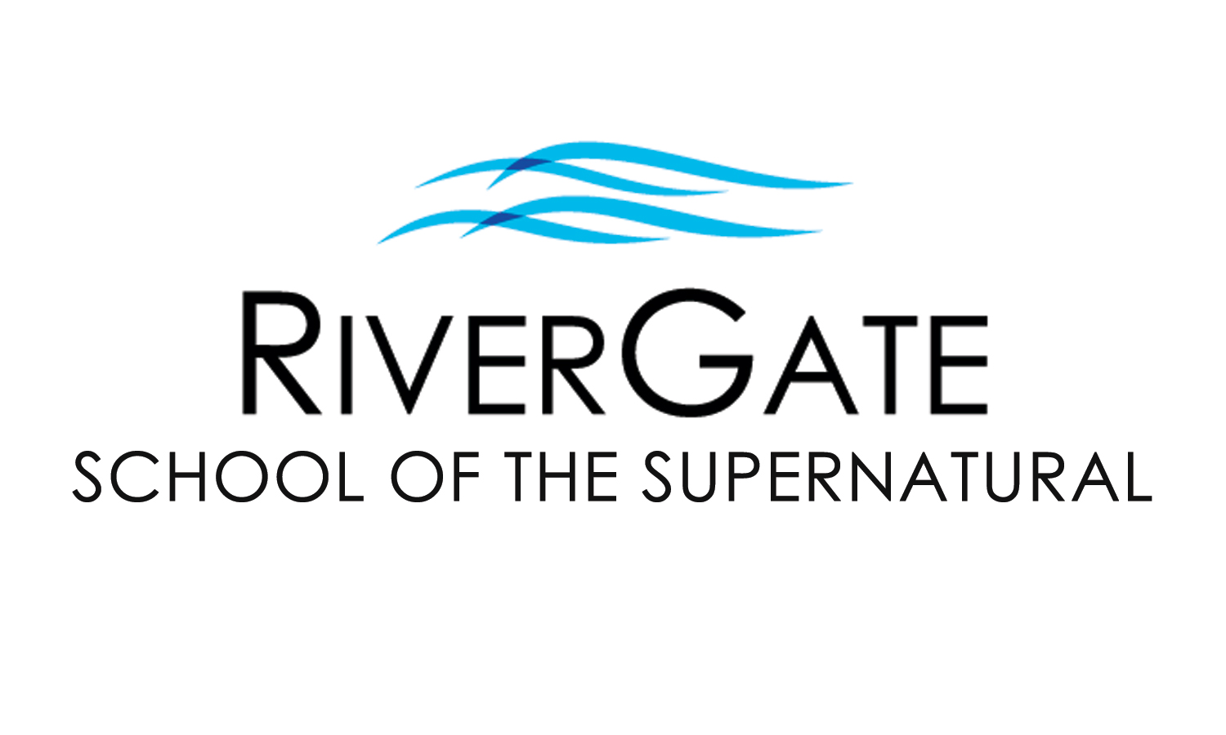

2022 SPRING CLASS OFFERINGS

The RiverGate School of the Supernatural seeks to raise up a new generation of humble, lovesick worshippers who have a prophetic edge with the character to match the anointing in their lives. We desire that you experience the Father’s love and learn how to give it away. RGSS consists of three levels of excellence and training. For more info, please contact us at 918-492-5511x39 or garyg@rivergatetulsa.org.

OUR MOST POPULAR WEDNESDAY NIGHT CLASSES:

HEALING OF THE HEART PART 1 (FL301-1) & PART 2 (FL301-2) BOTH ARE ALSO AVAILABLE IN AN ONLINE FORMAT!
Have you been a Christian for some time, or even a new Christian, and wounds and hurts from your past still haunt you? Perhaps difficult circumstances & relationships just seem to be a normal? This two-part class has been developed to help you be set free from your past. Topics include the importance of forgiveness, father/mother issues, overcoming rejection & abandonment, healing from abuse, performance orientation, inner vows & bitter root judgments, and more! (Enrollment includes all materials.)
PART 1 (FL301-1) PART 2 (FL301-2) (Taught live this semester by Pastor Cristin)
Prerequisites: None Prerequisites: Healing of the Heart Part 1 (FL301-1)
Registration: $49 by January 12th, 2022 ($74 after Jan 12th) Registration: $49 by January 12th, 2022 ($74 after Jan 12th)
Class Dates: Weds @ 6:30pm for 9 wks, beginning Jan 26th Class Dates: Weds @ 6:30pm for 8 wks beginning Jan 26th
Note: No classes on Weds, March 16th, 2022 for Spring Break. Additionally, Part 2 will not meet on February 16th, 2022 (but Part 1 will).

HOW TO HEAR THE VOICE OF GOD (FL305)
This class will teach you how to discern God’s voice from all other voices that clamor for your attention. You’ll receive vital keys to increase the intimacy of your prayer time, to be still before the Lord, as well as recognize His speech. You’ll experience a depth of relationship with God you never thought possible!
Prerequisites: None / Early Registration: $45*** before January 19th, 2022 / Registration: $70*** after January 19th, 2022
Class Dates: Wednesday evenings @ 6:30pm for 10 weeks beginning January 26th (no class March 16th for Spring Break)
***This class includes the cost of the workbook that goes along with the teaching. For an additional $33, the student may also purchase the Interactive Learning Experience Workbook, not required for this class but recommended as a great resource. Please indicate whether or not you want this workbook at the time of enrollment.

OUR MOST POPULAR SUNDAY NIGHT CLASSES:

BREAKING FREE PART 1 (FL302-1) & PART 2 (FL302-2) BOTH ARE ALSO AVAILABLE IN AN ONLINE FORMAT!
Do you find yourself struggling with the same issues, health problems, and personal conflicts? Chances are likely you have “open doors” that have allowed the demonic to have access & trespass in your life, possibly harassing you & your family for years, even generations. In Part 1, you’ll identify the “open doors” in your life and learn how to experience freedom from torment. You’ll receive personal ministry & hands-on training for living a lifestyle of freedom. Part 2 goes deeper, helping students identify both familiar & religious spirits and investigate how the enemy would like us to become unwitting instruments through the four faces of Jezebel. By conclusion, students learn how to build a shield of honor & prepare for a visitation from the Lord. Pastor Cristin Hamman teaches Breaking Free Part 1.
(Correspondence options are also available for Part 2, please contact the RGSS office.)
PART 1 (FL302-1) PART 2 (FL302-2)
Prerequisites: None Prerequisites: Breaking Free Part 1 (FL302-1)
Registration: $65 by January 16th, 2022 ($90 after Jan 16th) Registration: $84 by January 16th, 2022 ($109 after Jan 16th)
Class Dates: Sun @ 6pm for 8 wks, beginning Jan 30th, 2022 Class Dates: Sun @ 6pm for 10 wks beginning Jan 30th, 2022
Note: Registration for these classes includes the cost of all materials. (No classes on Sun, March 13th, 2022 for Spring Break.)
BREAKING FREE WEEKEND is Saturday, March 26th, 2022 (8:30am – 4pm) and is required of Breaking Free Part 1 students. This date/event is optional for Breaking Free Part 2 students. Cost for this event is included in enrollment. Alumni of Breaking Free 1 may participate in Breaking Free Weekend for $20 w/ advanced registration or $25 at the door.
MORE CLASSES FEATURED ON THE REVERSE SIDE

Please fill out the information below & on the reverse side. You may detach & turn it in with the offering or at the front desk before/after service.

Name: Today’s Date: / /

Address: City: Zip:

Cell Phone: Email:

Concerning Children’s Ministry, I will need (indicate # in blank): ____ None _____ Nursery/Preschool _____ Elementary _____ Youth

Check one: I am enrolling with payment today. (please complete reverse side)
I would like to be contacted before enrolling or to enroll over the phone. Please call me.

MORE SUNDAY NIGHT CLASSES:

OMEGA COURSE: UNDERSTANDING END TIMES (FL403) THIS CLASS WILL BE AVAILABLE IN AN ONLINE FORMAT!
A time is coming when life as we know it will be forever changed. “The End Times” will bring the most intense trouble the world and the church has ever witnessed, but will also usher in the greatest revival the Church has ever experienced. Those who are prepared for these adventurous times will not only stand, but will also help others find strength as they experience more of the Father’s love and power. Jesus desires that before this all begins, we would be prepared and understanding what He is about to do. This class, facilitated by Pastor Joel Budd, will not only help you understand what is to come, but will draw you into deeper intimacy with the Bridegroom and the Father.
Prerequisites: none
Early Registration: $44 by January 16th, 2022 / Registration: $69 after January 16th, 2022 (enrollment includes materials)
Class Dates: Sun nights at 6pm for 8 weeks beginning January 30th, 2022 (no class on March 13th for Spring Break)

PROPHETIC EVANGELISM (PI203)
While people everywhere are longing for a real spiritual connection, many traditional methods of sharing God’s love are received as a turn-off in this class, developed by Doug Addison, you will learn to hear God for others and communicate His love and truth in a way that can be understood by those without a religious background. You’ll also gain hands-on experience as we practice in the marketplace together.
Prerequisites: Healing of the Heart Part 1 (FL301-1)
Early Registration: $34 by January 16th, 2022 / Registration: $59 after January 16th, 2022 (enrollment includes materials)
Class Dates: Sun nights at 6pm for 4 weeks beginning January 30th, 2022

PROPHETIC TATTOO & PIERCING INTERPRETATION (PI204)
Over a billion people on earth have tattoos and piercings and every one of them needs more of God’s love. In this class, developed by Doug Addison, you will learn to recognize and interpret prophetic and symbolic messages of tattoos and piercings in order to deliver unexpected, non-religious interpretations and impartations of the Father’s love, possibly to individuals who do not believe in God or would never expect to find themselves in a church. (Please note that this class is not an endorsement or promotion of tattoos and piercings.)
Prerequisites: Prophetic Evangelism (PI203)
Early Registration: $34 by February 20th, 2022 / Registration: $59 after February 20th, 2022
Class Dates: Sun nights at 6pm for 5 weeks beginning March 6th, 2022 (no class on March 13th for Spring Break)

MORE AMAZING CLASSES THIS SEMESTER:

FOUNDATIONS (CHRISTIANITY 101)
In today’s world of complicated messages, it’s refreshing to have a simple but profound message of God’s love and grace. It’s comforting to know His purpose for us as believers. Whether one is new to following Jesus or has been for quite some time, sometimes it’s good to stop and consider some of the foundational truths of our faith. In this class, students will establish (or reestablish) the solid foundation of their faith, as well as develop invaluable tools to know God and walk in partnership with Him. Together we will discover Jesus in a new way and learn how to help others discover Him too!
Prerequisite: None
Early Registration: $15 by January 16th, 2022 / Registration: $30 after January 16th, 2022
Class Dates: Sundays at 9am for 10 weeks beginning January 30th, 2022 (no class on March 13th for Spring Break)

WATER BAPTISM (FL102)
This class gives the Bible’s clear & definite teaching on the significance & symbolism of water baptism, including why people are baptized when they become believers, what the purpose is, who should be baptized, and how a baptism should be conducted. Those who complete the class are invited to participate in the water baptism that same day during the main service. Participants should bring a towel and change of clothes. (Students under 12 years must receive preapproval from Pastor Cristin.)
Prerequisites: None / Cost: Free / Class Date: Sun morning, March 28th, 2022 @ 9am (baptism during the 10:30am service)

Child/Dependent Care: Children’s/Youth Ministry are offered during regular service times, in conjunction with our classes. For any classes/events outside of regular RGC service times, child/dependent care is not provided and must be arranged by the RGSS student, as only nursing babies are permitted in class.

Please fill out the information below & on the reverse side. You may detach & turn it in with the offering or at the front desk before/after service.

Class(es) I am interested in and/or would like to enroll in:

Class 1: In person: Online: Price:

Class 2: In person: Online: Price:

If enrolling by credit card, both sides must be filled out completely. Total:

Debit/Credit Card #: - - - Exp. Date: /

Print name: Signature:

We love you as you are and want to give away what we have learned over our years of ministry and we want you to be lessed mightily as God takes you to where He knows you can be. Come join us in the School of the Supernatural this semester. This journey together will be a wonderful adventure in the Father’s love & power!
Office Use Only:
Cash
Check #:
Credit

Processed date:

