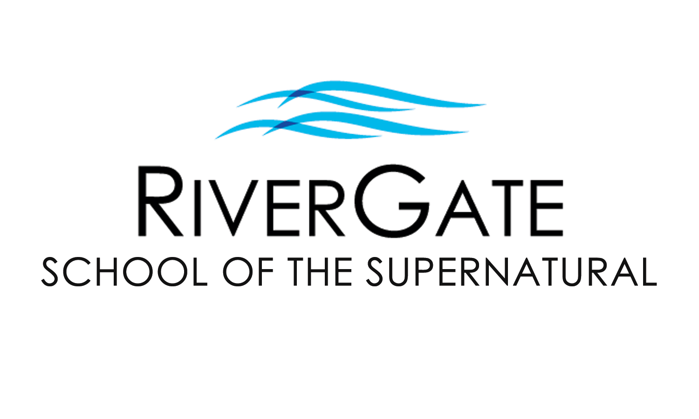

2021 FALL CLASS OFFERINGS

The RiverGate School of the Supernatural seeks to raise up a new generation of humble, lovesick worshippers who have a prophetic edge with the character to match the anointing in their lives. We desire that you experience the Father’s love and learn how to give it away. RGSS consists of three levels of excellence and training. For more info, please contact us at 918-492-5511x39 or garyg@rivergatetulsa.org.

OUR MOST POPULAR SUNDAY NIGHT CLASSES:

BREAKING FREE PART 1 (FL302-1) & PART 2 (FL302-2) AVAILABLE IN BOTH IN-PERSON AND ONLINE FORMATS!
Do you find yourself struggling with the same issues, health problems, and personal conflicts? Chances are likely you have “open doors” that have allowed the demonic to have access & trespass in your life, possibly harassing you & your family for years, even generations. In Part 1, you’ll identify the “open doors” in your life and learn how to experience freedom from torment. You’ll receive personal ministry & hands-on training for living a lifestyle of freedom. Part 2 goes deeper, helping students identify both Familiar & Religious Spirits and investigate how the enemy would like us to become unwitting instruments through the four faces of Jezebel. By conclusion, students learn how to build a shield of honor & prepare for a visitation from the Lord. This class was written & developed by Pastor Cristin Hamman.

PART 1 (FL302-1) PART 2 (FL302-2)
Prerequisites: None Prerequisites: Breaking Free Part 1 (FL302-1)
Registration: $65 by Sept 5th, 2021 ($90 after Sept 5th) Registration: $84 by Sept0 5th, 2021 ($109 after Sept 5th)
Class Dates: Sun@6pm for 8 wks, beginning Sept 19th Class Dates: Sun@6pm for 10 wks beginning Sept 19th
Note: Registration for these classes includes the cost of all materials.
BREAKING FREE WEEKEND is Saturday, Nov 13th, 2021 (8:30am – 4pm) and is required of Breaking Free Part 1 students. This date/event is optional for Breaking Free Part 2 students. Cost for this event is included in enrollment. Alumni of Breaking Free 1 may participate in Breaking Free Weekend for $20 w/ advanced registration or $25 at the door.

OUR MOST POPULAR WEDNESDAY NIGHT CLASSES:

HEALING OF THE HEART PART 1 (FL301-1) THIS CLASS IS AVAILABLE IN BOTH IN-PERSON AND ONLINE FORMATS!
Have you been a Christian for some time, or even a new Christian, and wounds and hurts from your past still haunt you? Perhaps difficult circumstances & relationships just seem to be a normal? This two-part class has been developed to help you be set free from your past. Topics include the importance of forgiveness, father/mother issues, overcoming rejection & abandonment, performance orientation, inner vows & bitter root judgments, and more! (Enrollment includes materials.) Pastor Cristin Hamman will teach this class live.
PART 1 (FL301-1) *Please note that Healing of the Heart Part 2 will not be offered this semester
Prerequisites: none we are working to revise this class. It will be offered next in Spring 2022.
Registration: $49 by Aug 25th, 2021 ($74 after Aug 25th, 2021)
Class Dates: Wed nights @ 6:30pm for 8 wks – Sept 8th – Nov 10th, 2021 (no classes on Sept 29th and Oct 20th)

DREAM LANGUAGE (PI203)
God desires to communicate with us through dreams and night-time visions, but it is only as we gain understanding of how to unlock these hidden messages that we will be able to take full advantage of what He’s saying. In this class you will learn to listen to the language of your own dreams, strategies and skills for having an active dream life, basic skills for interpreting dreams, and the everyday uses for this form of prophetic revelation. This class was written and developed by Pastor Cristin Hamman.
Prerequisites: Effective Prophetic (PI202)
Early Registration: $39 by Aug 25th, 2021 / Registration: $54 after Aug 25th, 2021 (Enrollment covers the cost of all materials.)
Class Dates: Wed nights @ 6:30pm for 10 wks – Sept 8th – Nov 17th, 2021 (no class on Wed, Oct 20th for Fall Break)

MORE CLASSES FEATURED ON THE REVERSE SIDE

Please fill out the information below & on the reverse side. You may detach & turn it in with the offering or at the front desk before/after service.

Name: Today’s Date: / /

Address: City: Zip:

Cell Phone: Email:

I am a RiverGate Church (circle one): MEMBER ATTENDER VISITOR STUDENT ONLY

Check one: I am enrolling with payment today. (please complete reverse side)
I would like to be contacted before enrolling or to enroll over the phone. Please call me.

MORE SUNDAY NIGHT CLASSES:

POWER PORTALS (HD104) THIS CLASS IS AVAILABLE IN BOTH IN-PERSON AND ONLINE FORMATS!
All Christians are intended to operate in the supernatural realm but many aren’t sure how. Within portals I tis possible for us to experience God’s presence, an abundance of healing, spontaneous joy, signs and wonders, angelic activity, an increase in spiritual dreams and visions, extravagant provision, and so much more. Some portals can be activated in our own bodies while others are occur around us. In this class you will hear personal stories of supernatural encounters as you learn how to encounter the supernatural yourself. This class will be facilitated by Pastor Joel Budd.
Prerequisites: None / Early Registration: $39 before Sept 5th, 2021 / Registration: $64 after Sept 5th, 2021
Class Dates: Sunday evenings @ 6pm for 9 weeks beginning Sept 19th^{d} through Nov 21st, 2021 (no class on Oct 17th)

ENCOUNTERS
After reading an excerpt from Supernatural: The Life of William Branham by Owen Jorgensen, the group encounters the Holy Spirit as participants learn how to receive and give words of knowledge. Imagine being able to give a witness’ account of seeing a blind person’s sight restored! Even better, imagine being the one whom God uses to do that!! Everyone is welcome – come to be healed, to watch, to learn how to get words of knowledge and minister healing to others, and to see the glory of God manifested. In this class you WILL encounter God! This class is hosted by Pastor Linda Budd.
Prerequisites: None / Registration: None
Class Dates: Every Sunday night at 6pm

MORE WEDNESDAY NIGHT CLASSES:

HOW TO HEAR THE VOICE OF GOD (FL305)
This class will teach you how to discern God’s voice from all other voices that clamor for your attention. You’ll receive vital keys to increase the intimacy of your prayer time, to be still before the Lord, as well as recognize His speech. You’ll experience a depth of relationship with God you never thought possible!
Prerequisites: None / Early Registration: $39*** before Aug 25th, 2021 / Registration: $65*** after Aug 25th, 2021
Class Dates: Wednesday evenings @ 6:30pm for 8 weeks beginning Sept 8th through Nov10th, 2021 (no class Sept 29th & Oct 20th)
***This class includes the cost of the workbook that goes along with the teaching. For an additional $25, the student may also purchase the Interactive Learning Experience Workbook, not required for this class but recommended as a great resource. Please indicate whether or not you want this workbook at the time of enrollment.

MORE AMAZING OPPORTUNITIES THIS SEMESTER:

WATER BAPTISM (FL101)
This class gives the Bible’s clear & definite teaching on the significance & symbolism of water baptism, including why people are baptized when they become believers, what the purpose is, who should be baptized, and how a baptism should be conducted. Those who complete the class are invited to participate in the water baptism that same day during the main service. Participants should bring a towel and change of clothes. (Students under 12yrs must receive preapproval from Pastor Cristin Hamman.)
Prerequisites: None / Cost: Free / Class Date: Sun morning, November 14th, 2021 @ 9am (baptism during the 10:30am service)

BREAKING FREE WEEKEND (BFW)
This ministry event is only for current students of Breaking Free 1 or 2, as well as alumni of Breaking Free 1. During this ministry event, participants will receive new levels of breakthrough and deliverance through corporate prayers and ministry activities. Additionally, participants will each receive a personal prophetic word, prayer for healing ministry, and so much more.
Prerequisites: Current enrollment or completion of Breaking Free 1.
Early Registration: No cost for current Breaking Free 1 or 2 students. $25 by Nov 7th / Registration: $35 for alumni after Nov 7th.
Event Date: Saturday, November 13th, 2021 (8:30am-4pm)
Note: Child/dependent care is not provided.

Child/Dependent Care: Children’s/Youth Ministry are offered during regular service times, in conjunction with our classes. For any classes/events outside of regular RGC service times, child/dependent care is not provided and must be arranged by the RGSS student, as only nursing babies are permitted in class.

Please fill out the information below & on the reverse side. You may detach & turn it in with the offering or at the front desk before/after service.

Class(es) I am interested in and/or would like to enroll in:

Class 1: In person: Online: Price:

Class 1: In person: Online: Price:

If enrolling by credit card, both sides must be filled out completely. Total:

Debit/Credit Card #: - - - Exp. Date: /

Print name: Signature:
We love you as you are and want to give away what we have learned over our years of ministry and we want you to be lessed mightily as God takes you to where He knows you can be. Come join us in the School of the Supernatural this semester. This journey together will be a wonderful adventure in the Father’s love & power!
Office Use Only:
Cash
Check #:
Credit

Processed date:

